Meshaal Mouawad
Mississippi State University, Electrical and Computer Engineering Department,
This is a summary report of my research assignments I was given by my advisor during my PhD program
Summary Report: week 17
For Research Assignments of my PhD

July 19, 2021
Voronoi Diagram, TSP, and DWA Stages

- Environmental Exploration: to avoid the obstacles and set the global path, we have constructed the Voronoi Diagram. And then we pick some local points $P_{n}$ such that $P_{1}, P_{2}, P_{3}…P_{n}$is a target local points on the Voronoi Diagram.
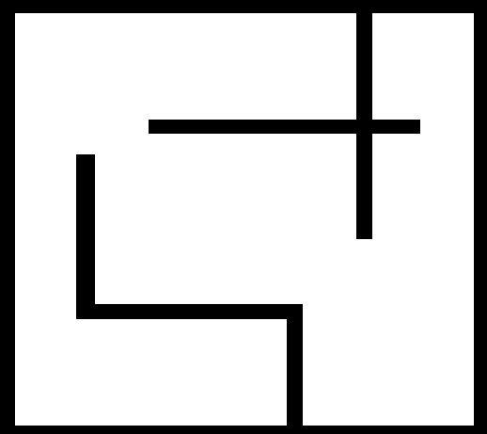
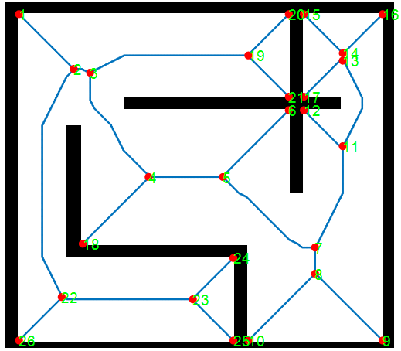
Figure. 2 the result from the matlab code

- Multi-goal path planning: We then find the shortest path between the local points $P_{n}$ which we used TSP (Travelling salesman problem) algorithms.

- is applied to connect some goals/waypoints that we need to explore, rescue, and reach. Running your TSP algorithm to connect some points such as green stars:
I used another Python code for TSP and successfully run it! Gorubi Module was used for optimization. The output for the optimal path is:

[(0, 1), (1, 2), (2, 3), (3, 4), (4, 5), (5, 0)]

Time taken by MTZ formulation = 1.2135167121887207

The solution visualization is:
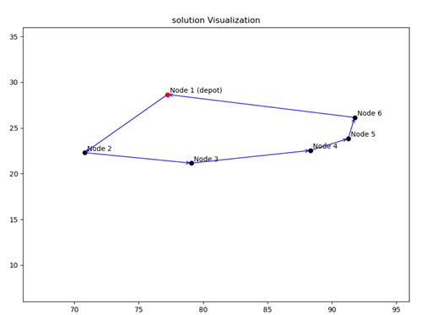

- Local navigator using DWA (Dynamic Window Approach): ) method to walk a mobile robot from starting point to goal along the edges of built GVD. DWA to navigate the robot to connect multiple goals depicted by the green stars.

I am waiting the code you told me to send it to me

After that, the next step will be the Mapping

Conclusion

VD
Generate VD
TSP:
to connect multiple points, and minimize traveling distant.

DWA:
Path planning and local navigation. To walk the robot from start point to the goal along the edge of GVD.

Mapping:

